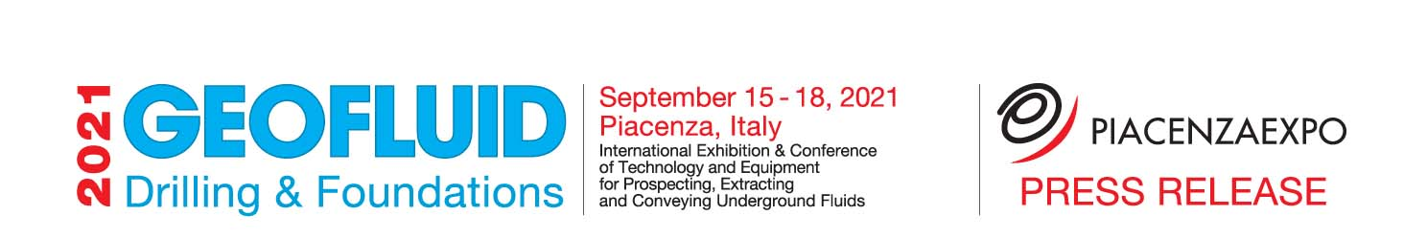

Piacenza Expo is preparing to experience the nextedition of Geofluid, which will take place from 15 to 18 September at the Piacenza exhibition centre, as a very important moment for the sector it represents.
The most important international trade fair for the drilling&foundations sector finds new stimuli from the proliferation of topical issues for trade visitors. Geothermal energy, underground construction sites 4.0, new trenchless technologies, dewatering and groundwater, energy transition, reductions in atmospheric emissions and geoengineering, new materials for transporting fluids are the themes that will underpin the exhibition part of Geofluid 2021.

The 2021 edition will be even more of a strategic moment to understand how the continental economy, international orders and large-scale public infrastructure works can generate income for the gross domestic product.
The next edition is therefore set to be an important moment for planning future work in the drilling, foundation and underground sector.
In the European Union's 2021-2027 budget, a large part of the resources of the European Regional Development Fund (ERDF) will be directed to environment-related measures: more than 70 billion for renewable energies, decarbonisation and energy efficiency.

It is quite clear that future scenarios will tend to be linked to the economic resources at stake to ensure, on the one hand, the maintenance of water supplies and, on the other, environmental protection through the increasingly important use of renewable energies such as geothermal energy.
A special effort will also be made to manage natural gas through the trans-European networks. Major works and installations will be the subject of projects and orders over the next decade in order to arrive in 2050 with a cleaner European continent.

Geofluid 2021 has already reconfirmed almost all the 280 direct exhibitors for an edition that will involve the entire territory in order to offer a complete exhibition experience to participating companies and professional visitors.

Geofluid
international exhibition of technologies and equipment for research, extraction and transport of underground fluids
15-18 september 2021 www.geofluid.it –Piacenza - Italy
Organizers: Piacenza Expo tel. 0039.0523.602711 email: geofluid@piacenzaexpo.it

